**CSCE 5640: Operating System Design**

**Homework-3**

**Name:** Kishan Kumar Zalavadia

**EUID:** 11685261

4)

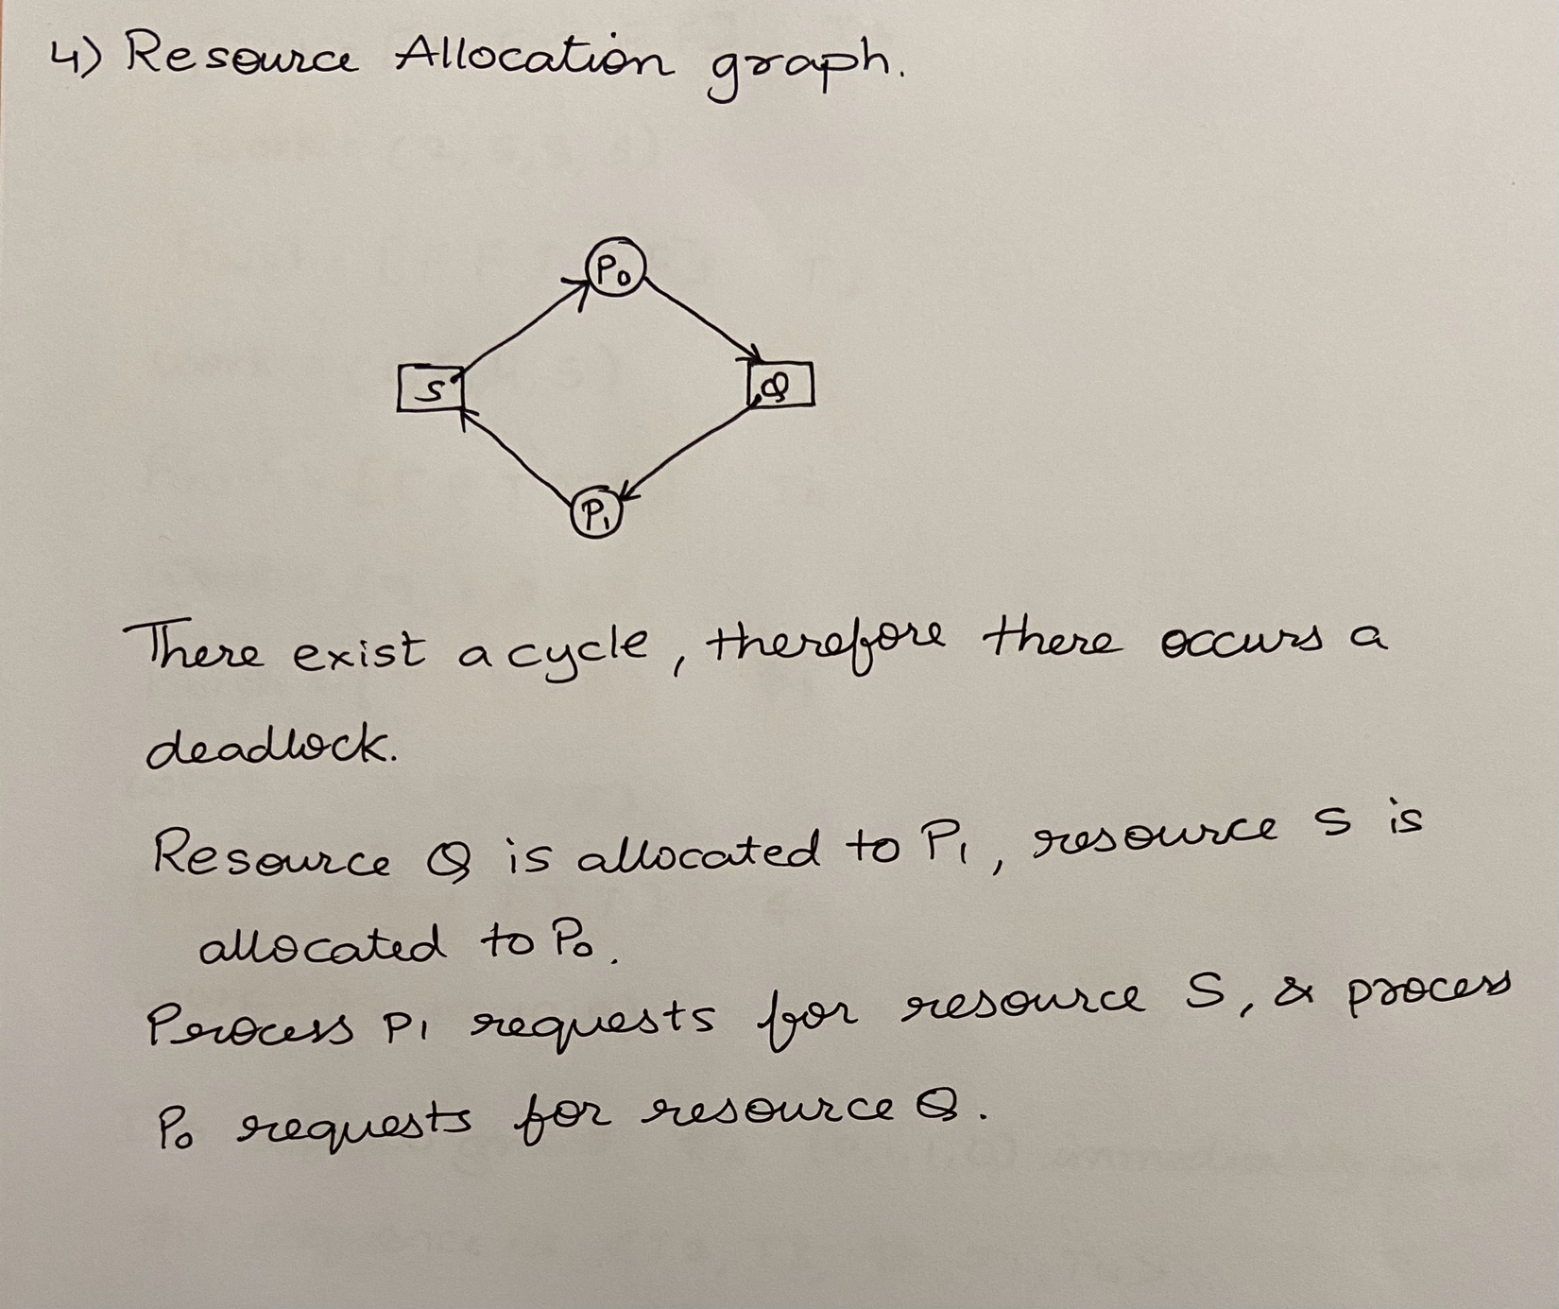

**Resource Allocation graph:**

There exists a cycle therefore there occurs a deadlock.

Resource Q is allocated to P1; resource S is allocated to P0.

Process P1 requests for resource S and process P0 requests for resource Q.

5)

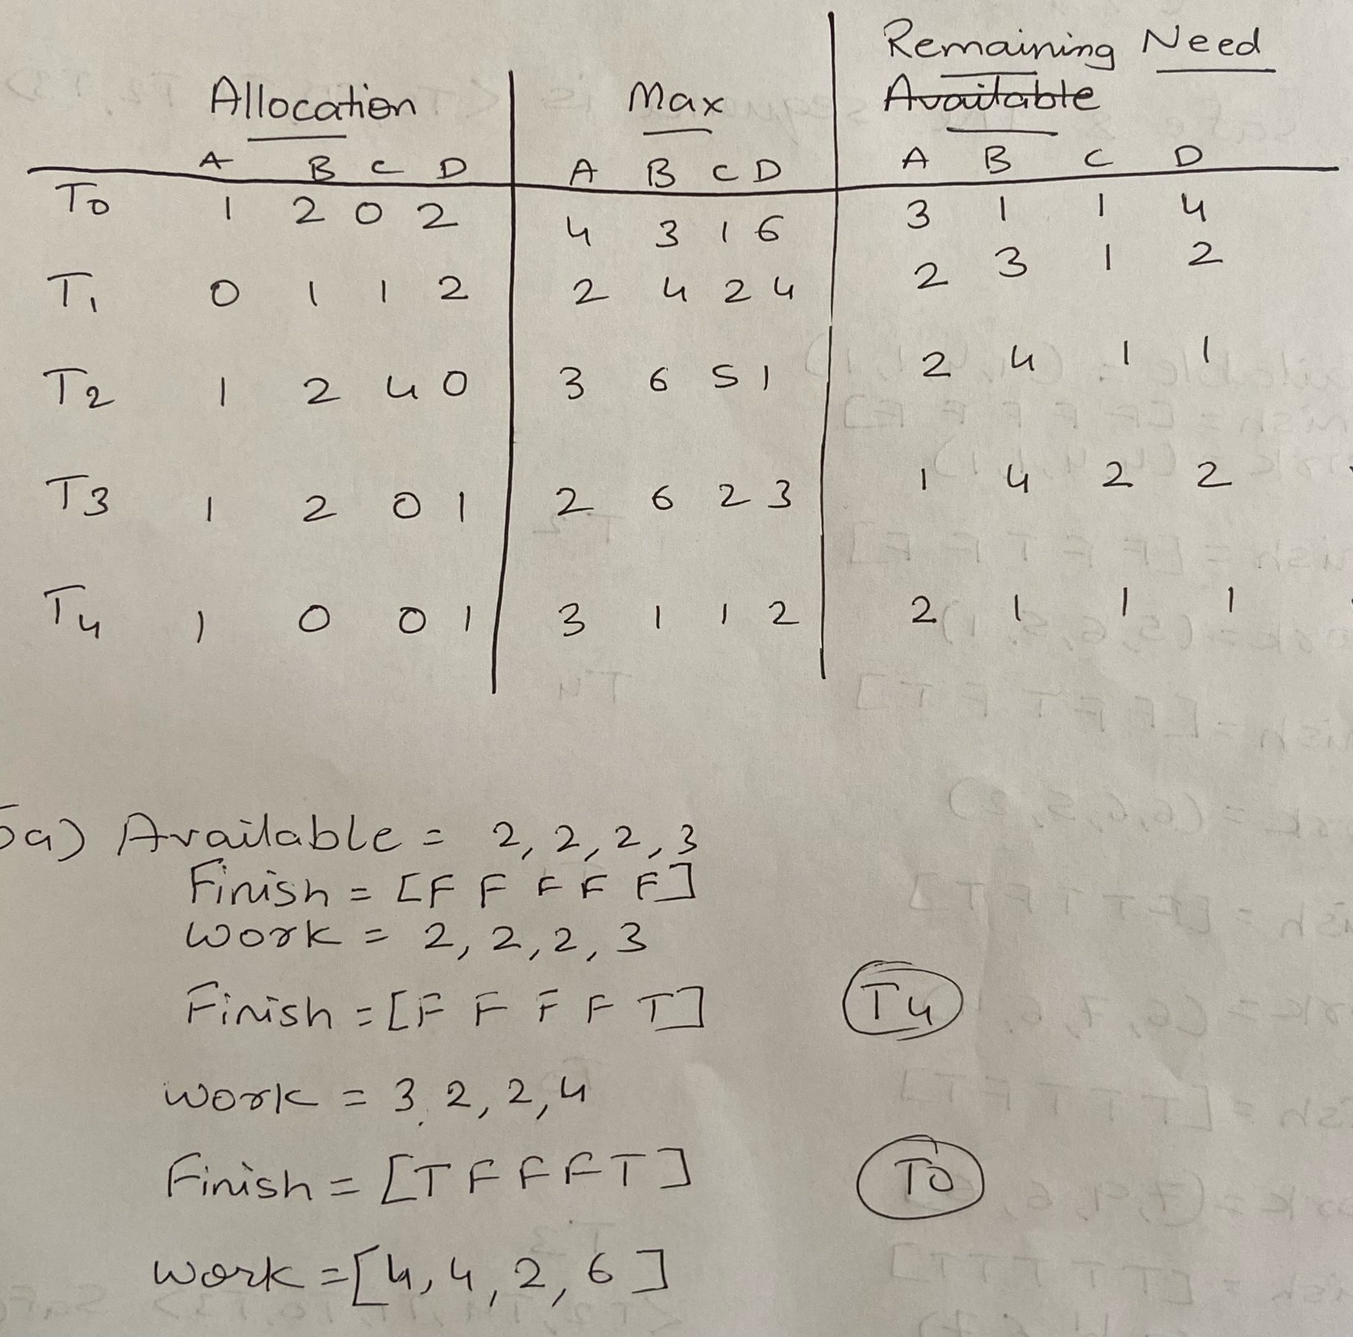

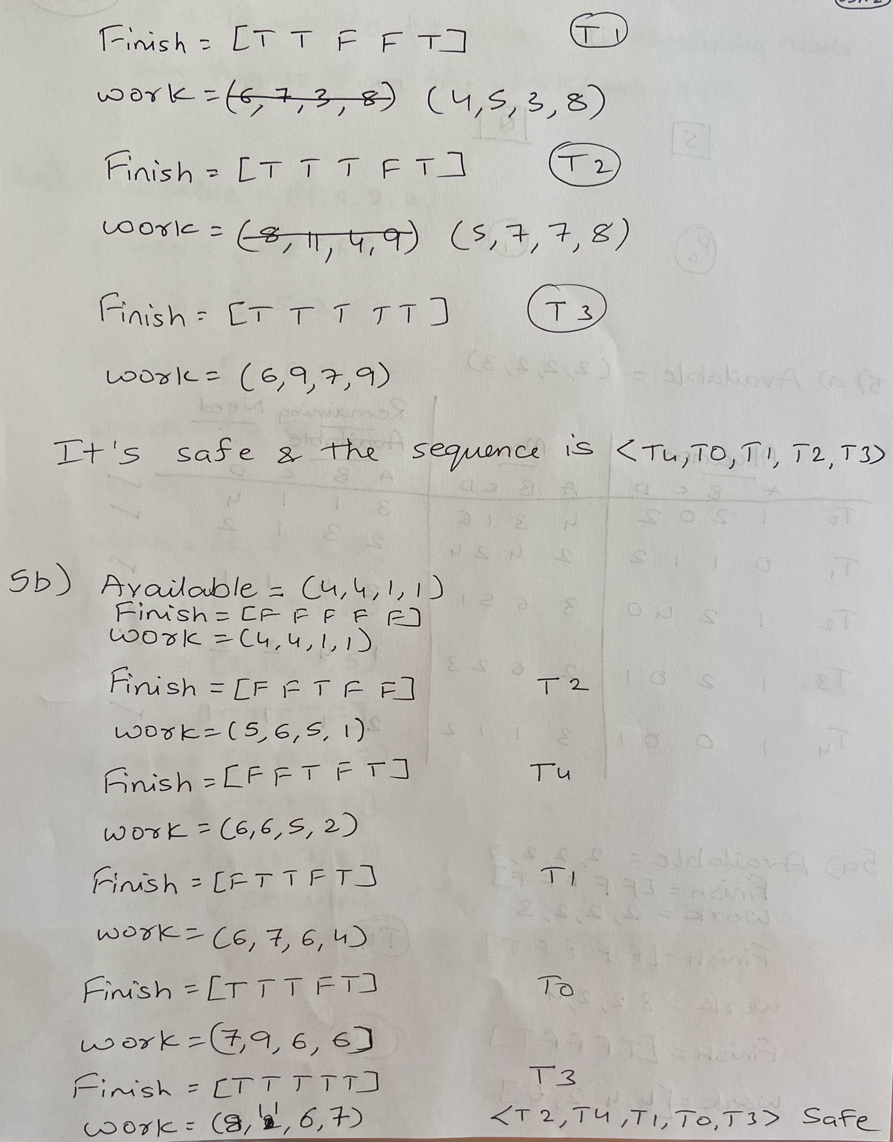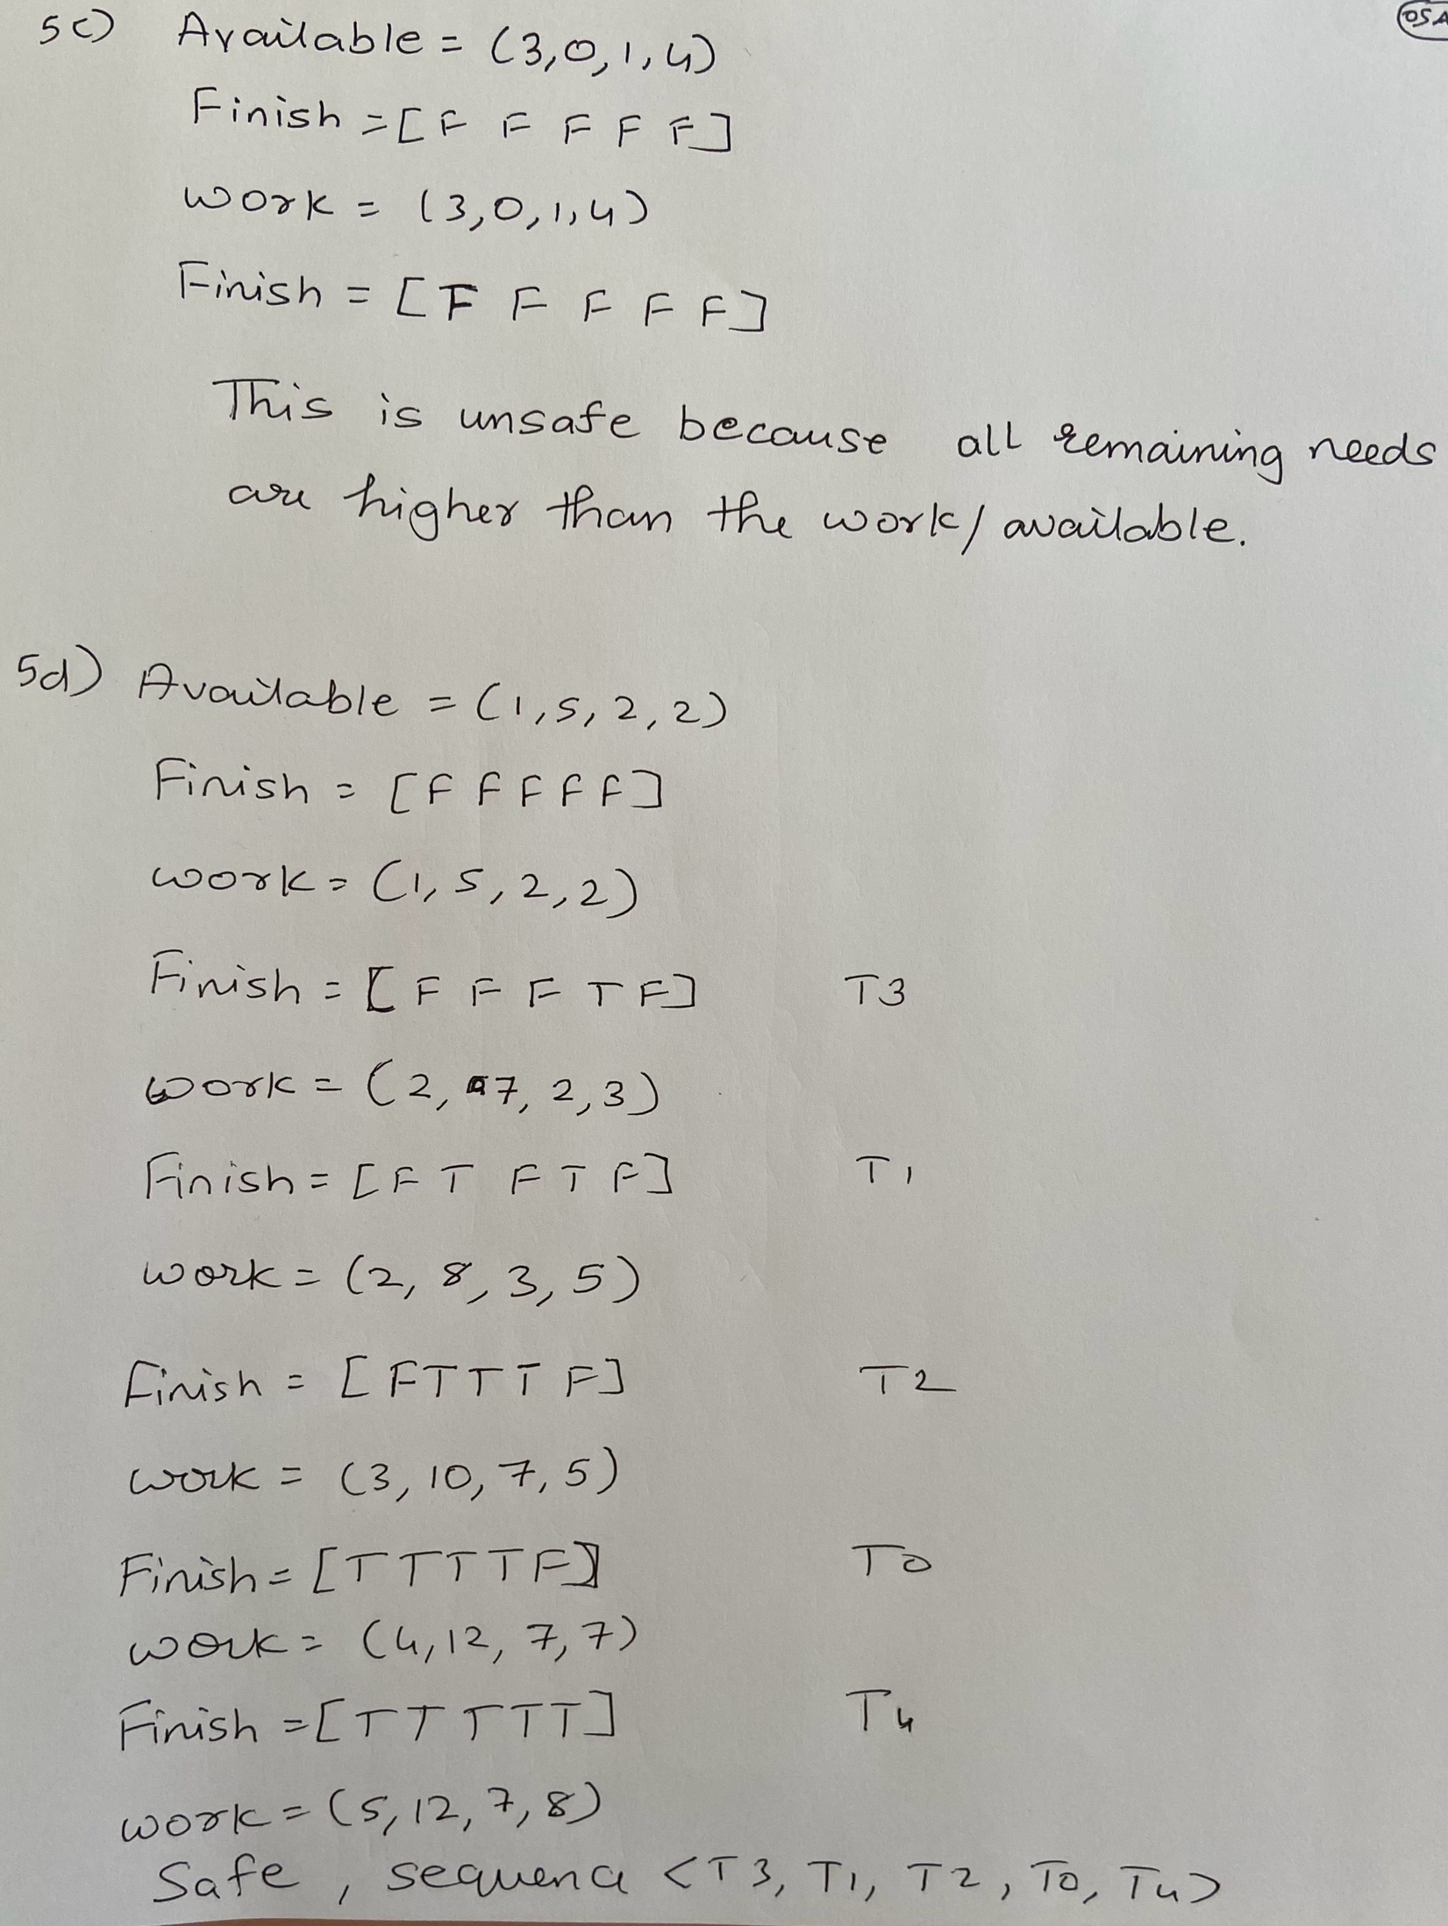

5a)

|  |  |  |  |
| --- | --- | --- | --- |
|  | Allocation | Max | Remaining Need |
|  | A,B,C,D | A,B,C,D | A,B,C,D |
| T0 | 1,2,0,2 | 4,3,1,6 | 3,1,1,4 |
| T1 | 0,1,1,2 | 2,4,2,4 | 2,3,1,2 |
| T2 | 1,2,4,0 | 3,6,5,1 | 2,4,1,1 |
| T3 | 1,2,0,1 | 2,6,2,3 | 1,4,2,2 |
| T4 | 1,0,0,1 | 3,1,1,2 | 2,1,1,1 |

Available = 2,2,2,3

Finish = [F F F F F]

Work – 2,2,2,3

Finish = [F F F F T] => T4

Work = 3,2,2,4

Finish = [T F F F T] => T0

Work = 4,4,2,6

Finish = [T T F F T] => T1

Work = 4,5,3,8

Finish = [T T T F T] => T2

Work = 5,7,7,8

Finish [T T T T T] => T3

Work = 6,9,7,9

It’s safe and the sequence is <T4, T0, T1, T2, T3>

5b)

Available = 4,4,1,1

Finish = [FFFFF]

Work=4,4,1,1

Finish = [FFTFF] => T2

Work = 5,6,5,1

Finish = [FFTFT] => T4

Work = 6,6,5,2

Finish = [FTTFT] => T1

Work = 6,7,6,4

Finish = [TTTFT] => T0

Work = 7,9,6,6

Finish = [TTTTT] => T3

Work = 8,11,6,7

Safe => <T2,T4,T1,T0,T3>

5c)

Available = (3,0,1,4)

Finish = [FFFFF]

Work = (3,0,1,4)

Finish = [FFFFF]

This is unsafe because all remaining needs exceed the work/available.

5d)

Available = (1,5,2,2)

Finish - [FFFFF]

Work = 1,5,2,2

Finish = [FFFTF] => T3

Work = 2,7,2,3

Finish = FTFTF => T1

Work = 2,8,3,5

Finish = [FTTTF] => T2

Work = 3,10,7,5

Finish = [TTTTF] => T0

Work = 4,12,7,7

Finish = [TTTTT] => T4

Work = 5,12,7,8

Safe: Sequence= <T3,T1, T2, T0, T4>

6)

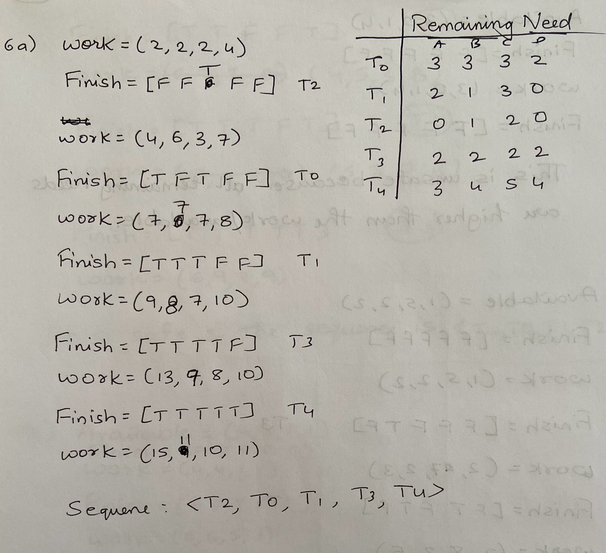

6a)

|  |  |
| --- | --- |
|  | **Remaining Need** |
|  | A,B,C,D |
| T0 | 3,3,3,2 |
| T1 | 2,1,3,0 |
| T2 | 0,1,2,0 |
| T3 | 2,2,2,2 |
| T4 | 3,4,5,4 |

Work = 2,2,2,4

Finish = [FFTFF] => T2

Work = 4,6,3,7

Finish = [TFTFF] => T0

Work = 7,7,7,8

Finish = [TTTFF] => T1

Work = 9,8,7,10

Finish = [TTTTF] => T3

Work = 13,9,8,10

Finish = [TTTTT] = > T4

Work = 15,11,10,11

Safe 🡺Sequence: <T2, T0, T1, T3, T4>

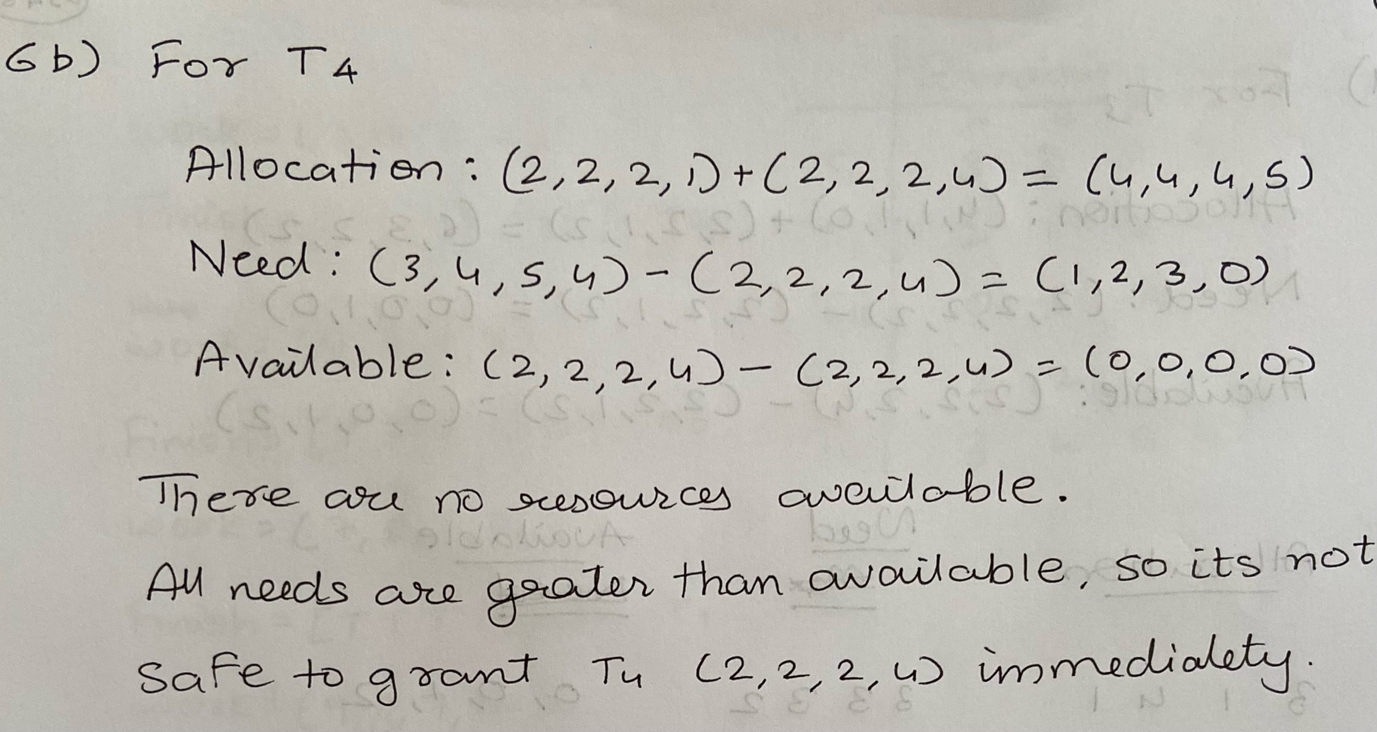

6b) For T4

Allocation: (2,2,2,1) + (2,2,2,4) = (4,4,4,5)

Need: (3,4,5,4) – (2,2,2,4) = (1,2,3,0)

Available: (2,2,2,4) – (2,2,2,4) = (0,0,0,0)

There are no resources available.

All needs are greater that available, so its not safe to grant T4 (2,2,2,4) immediately.

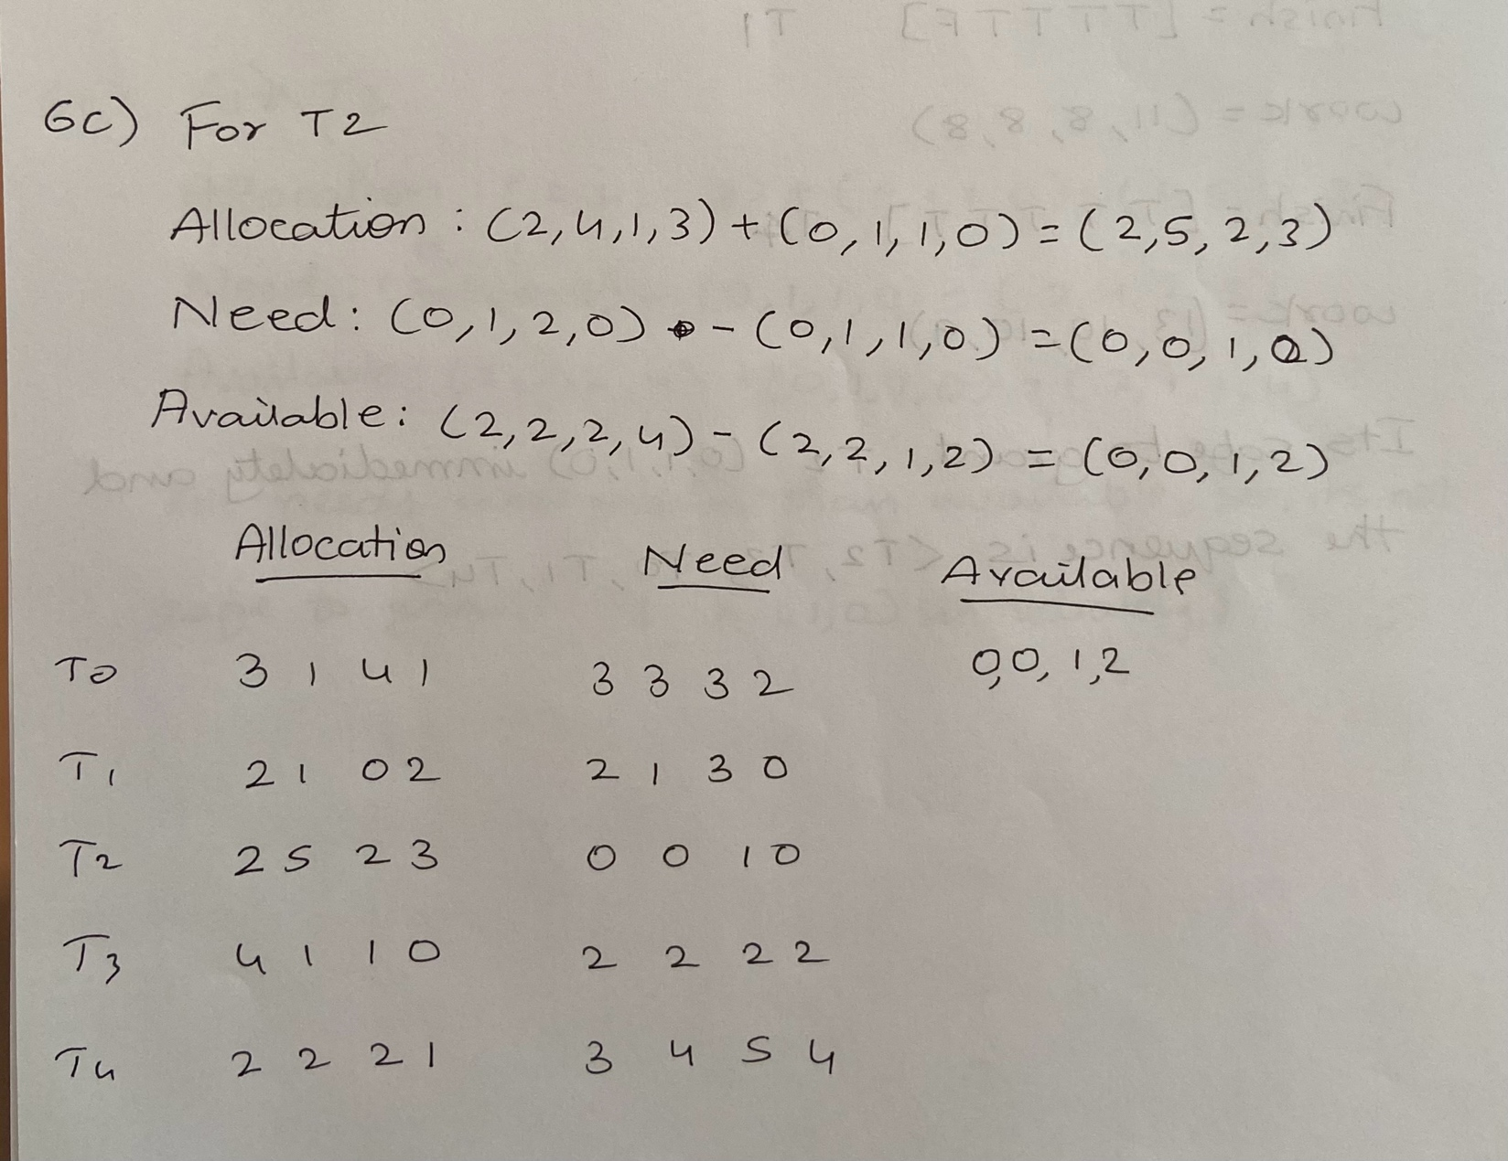

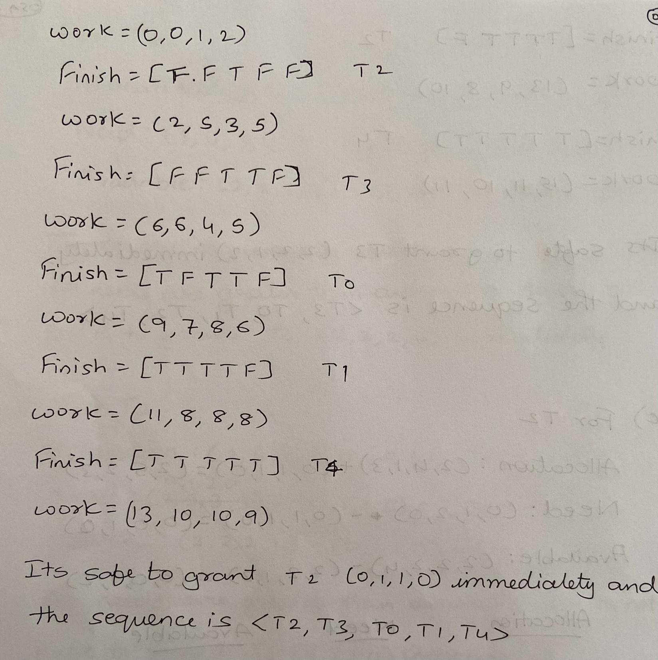

6c)

For T2

Allocation: (2,4,1,3) + (0,1,1,0) = (2,5,2,3)

Need: (0,1,2,0) - (0,1,1,0) = (0,0,1,0)

Available: (2,2,2,4) -(2,2,1,2) = (0,0,1,2)

|  |  |  |  |
| --- | --- | --- | --- |
|  | **Allocation** | **Need** | **Available** |
| T0 | 3,1,4,1 | 3,3,3,2 | 0,0,1,2 |
| T1 | 2,1,0,2 | 2,1,3,0 |  |
| T2 | 2,5,2,3 | 0,0,1,0 |  |
| T3 | 4,1,1,0 | 2,2,2,2 |  |
| T4 | 2,2,2,1 | 3,4,5,3 |  |

Work = 0,0,1,2

Finish = [FFTFF] => T2

Work = 2,,5,3,5

Finish = [FFTTF] => T3

Work = 6,6,4,5

Finish = [TFTTF] => T0

Work = 9,7,8,6

Finish = [TTTTF] => T1

Work = 11,8,8,8

Finish = [TTTTT] => T4

Work = 13,10,10,9

Its safe to grant T2 (0,1,1,0) immediately and the sequence is <T2,T3,T0,T1,T4>

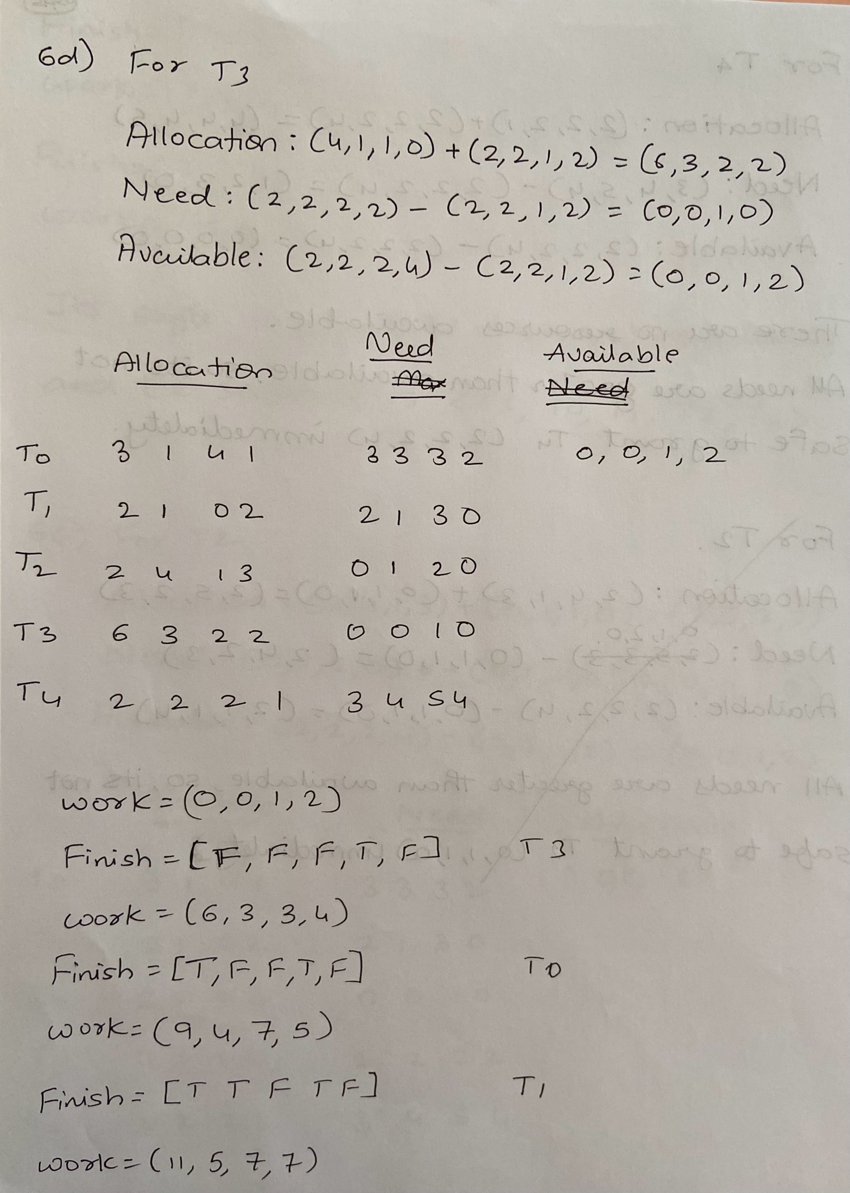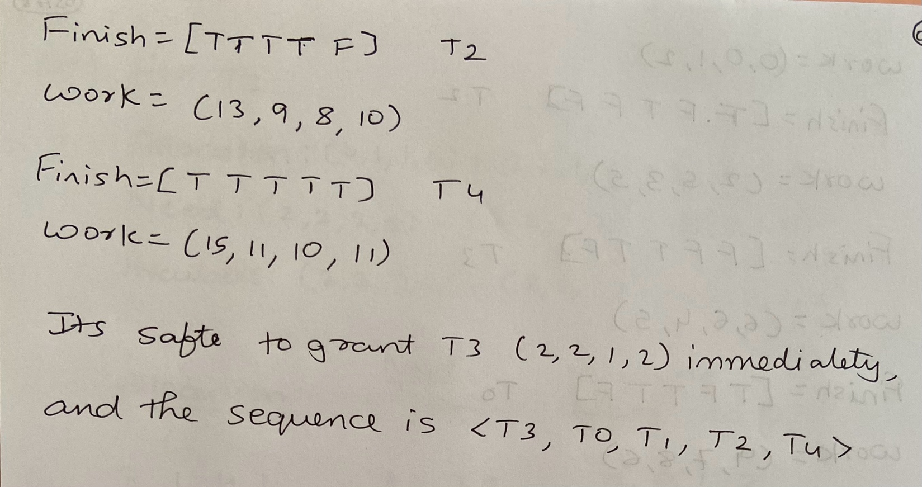

6d)

For T3

Allocation: (4,1,1,0) + (2,2,1,2) = (6,3,2,2)

Need: (2,2,2,2) - (2,2,1,2) = (0,0,1,0)

Available; (2,2,2,4) - (2,2,1,2) = (0,0,1,2)

Work = 0,0,1,2

Finish = [FFFTF] => T3

Work = 6,3,3,4

Finish = [TFFTF] => T0

Work = 9,4,7,5

Finish = [TTFTF] => T1

Work = 11,5,7,7

Finish = [TTTTF] => T2

Work = 13,9,8,10

Finish = [TTTTT] => T4

Work = 15,11,10,11

Its safe to grant T3 (2,2,1,2) immediately, and the sequence is <T3,T0,T1,T2,T4>.